Vertical Bar Chart

Definition
# Source: AI Source: Provided by: [Data Path: Persons Table -> ID Column: 1, Name_En Column: Motasem Essam] -> From: [Chatgpt (GPT‑5 Mini)] on [12/10/2025]
A Vertical Bar Chart is a type of bar chart where the bars extend vertically (upward) to represent values for different categories. The height of each bar corresponds to the value it represents.

Key Idea
# Source: AI Source: Provided by: [Data Path: Persons Table -> ID Column: 1, Name_En Column: Motasem Essam] -> From: [Chatgpt (GPT‑5 Mini)] on [12/10/2025]
Vertical bar charts are useful for comparing quantities across different categories, where categories are displayed along the horizontal (x-axis) and values are shown on the vertical (y-axis).

How It Works
# Source: AI Source: Provided by: [Data Path: Persons Table -> ID Column: 1, Name_En Column: Motasem Essam] -> From: [Chatgpt (GPT‑5 Mini)] on [12/10/2025]
- Place categories on the x-axis.
- Place numerical values on the y-axis.
- Draw vertical bars whose heights represent the values of each category.

Example
# Source: AI Source: Provided by: [Data Path: Persons Table -> ID Column: 1, Name_En Column: Motasem Essam] -> From: [Chatgpt (GPT‑5 Mini)] on [12/10/2025]
Dataset: Sales by Product
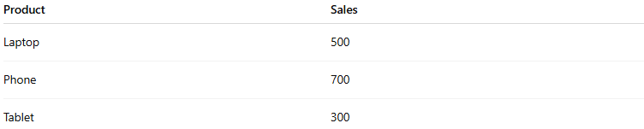
Product | Sales
Laptop | 500
Phone | 700
Tablet | 300
In a Vertical Bar Chart:
- The x-axis shows products (Laptop, Phone, Tablet).
- The y-axis shows sales values.
- Each product has a vertical bar whose height indicates sales.
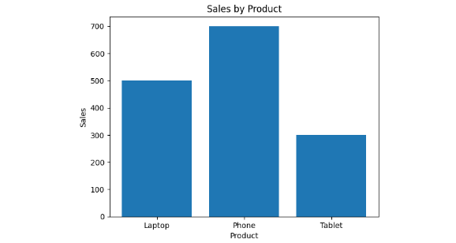

Applications
# Source: AI Source: Provided by: [Data Path: Persons Table -> ID Column: 1, Name_En Column: Motasem Essam] -> From: [Chatgpt (GPT‑5 Mini)] on [12/10/2025]
- Comparing sales across products
- Showing survey responses by category
- Analyzing population by groups
- Visualizing categorical data comparisons

Advantages
# Source: AI Source: Provided by: [Data Path: Persons Table -> ID Column: 1, Name_En Column: Motasem Essam] -> From: [Chatgpt (GPT‑5 Mini)] on [12/10/2025]
- Easy to read and interpret
- Clearly shows differences between categories
- Suitable for small to medium datasets

Disadvantages
# Source: AI Source: Provided by: [Data Path: Persons Table -> ID Column: 1, Name_En Column: Motasem Essam] -> From: [Chatgpt (GPT‑5 Mini)] on [12/10/2025]
- Not ideal for large numbers of categories
- Labels may become crowded on the x-axis

